PROFILE

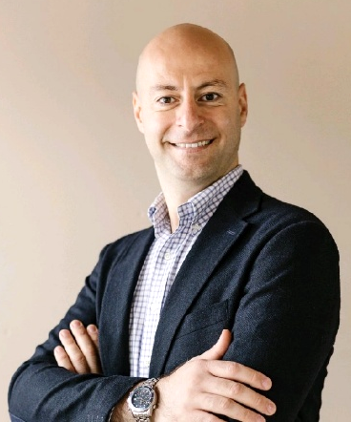
Commercial leader with 15+ years of international experience driving enterprise B2B growth for technology-enabled solutions—spanning AV, IT-enabled environments, and complex go-to-market execution across Europe, the Middle East, and India.
Track record of delivering multi-million-euro revenue, building partner ecosystems, and translating technical capabilities into clear customer value propositions. Strong in bridging between product environments, systems thinking, and commercial strategy.
Connecting technical systems, product environments, and commercial strategy to enable scalable smart workplace and related solutions.
Digitally driven, using CRM and AI tools (LLMs) to improve pipeline quality, communication, and sales productivity.

WORKING EXPERIENCE

05/2022 – Present | Sales and Business Development Director (EMEA & India)  Artome Oy, Hamburg & Cologne, Germany (Remote)  Sector: Audio Visual appliances  - Full commercial responsibility across Europe, Middle East, and India (excluding Nordics)  - 1M+ revenue through B2B AV solutions  - Network management, digital sales lead, pipeline management  - Aligned sales strategy with shareholder perspective  - Leveraging AI tools (LLMs) for sales efficiency  - Planning & executing international trade shows
09/2019 – 04/2022 | Digital & Web Solutions Consultant  Freelance, Hamburg, Germany  - Website development and digital consulting for SMEs  - Including e-Commerce platforms, UX & customer experience
09/2019 – 02/2021 | Technical Sales Trainee  Masa GmbH, Andernach, Germany  Sector: Manufacturing Plants for Concrete Products  - Temporary learning experience: Exposure to manufacturing-side sales and production systems
07/2017 – 09/2019 | Chief of Operations Manager (interim)  Marche-en-Famenne, Wallonie, Belgium  Sector: Cross Cultural Training and Consultancy  - Hiring, onboarding and training international sales teams  - Developing and optimizing the sales strategy  - Completing and advising on international key executive relocation
04/2017 | Relocation to Germany for personal reasons
12/2012 – 02/2017 | Co-Founder & Project Manager (while being employed at Futuretec)  Ftech Technical Services, Dubai, UAE  Sector: Large scale brick laying contracting  - Full planning and delivery of large-scale infrastructure projects:  - Khalifah Harbour in Abu Dhabi (Profit: 44 %) 450.000 sqm  - Jebel Ali Container Terminal 3 & 4, Dubai (Profit: 53%) 950.500 sqm  - Hamand Harbour, Doha (Profit: 35%) 800.000 sqm
11/2003 – 02/2017 | Sales Manager  Futuretech Engineering, Dubai, UAE  Sector: Distribution of production plants for concrete products  - Leading and developing 30+ employees across 5 countries  - International strategy development and market expansion  - Budget responsibility and key account management  - International negotiations: €2.2M+ revenue generated  - Planning & execution of international trade fairs
02/2001 – 11/2003 | Multiple positions as Sales Manager in different industries  - 04/2003 – 11/2003: Al Bahar Contracting, Dubai, UAE  - 01/2002 – 04/2003: ShowTime TV Channels, Dubai, UAE  - 02/2001 – 01/2002: Arab Digital Distribution, Dubai, UAE
08/1998 – 01/2001 | IT Administrator (parallel to BBA)  Skynet Worldwide Express, Dubai, UAE
05/1997 – 06/1998 | Customer Service  DHL Worldwide Express, Damascus, Syria

EDUCATION
09/1996 – 10/2000 | Bachelor Business Administration in Economics  Damascus University, Damascus, Syria  Recognized as Bachelor in Wirtschaftswissenschaften in Germany
08/1996 | High School Diploma (Abitur equivalent)  Sami Drubi High School, Damascus, Syria  - Completed two years ahead due to academic excellence

SKILLS
Sales Leadership | Strategic Sales Leadership & Revenue Growth; Go-to-Market Strategy & Execution; Forecasting & Pipeline Management
Commercial & BD | Business Development & Market Expansion (EMEA & APAC); Key Account & Channel Management; Contract Negotiation & Stakeholder Management
Leadership | Cross-Cultural Team Leadership (30+ employees); Hiring, Onboarding & Training; Partner/Network Management
Tools & Digital | CRM: Pipedrive; Microsoft 365; Digital Sales Transformation; Web: HTML, CSS ; AI: LLM usage for AI-driven sales optimization
Domain Expertise | Technical Sales: AV systems; Industrial equipment; Manufacturing plants for concrete products
Languages | Arabic (Native); English (Fluent); German (B2)

